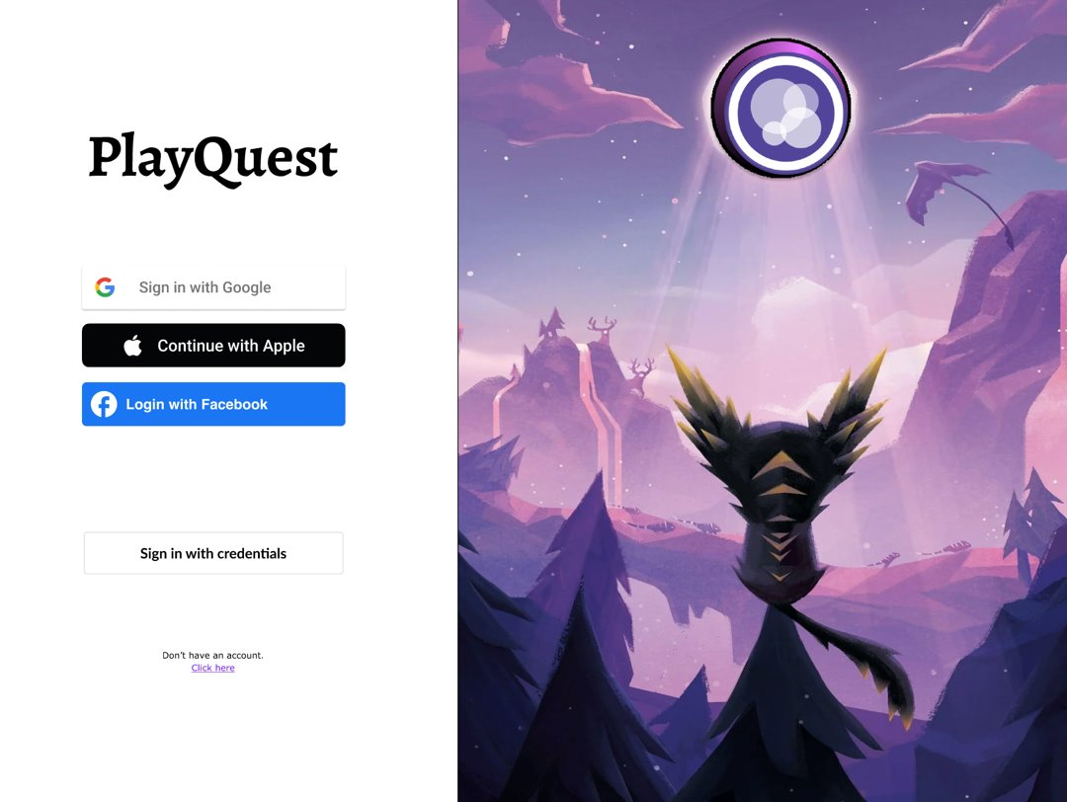

**PlayQuest**

by

*Gaurav Mehla (300347326)*

*Anshdeep Singh (300351832)*

Project is live at [aws.elasticbeanstalk.com](http://pq-env-2.eba-k7s5atp3.ap-southeast-1.elasticbeanstalk.com/) till Aug 5th, 2023 12:00AM

Table of Contents

Project Overview 3

Introduction 3

Business Case 3

Software Engineering Approach 3

Requirements Analysis 3

Functional Requirements 3

Non-functional Requirements 4

Use Cases 4

Activity Diagrams 4

Admin 4

User 5

Architecture 5

Wireframes 6

System Design 9

Database Structure 9

Sequence Diagram 9

Security and Compliance 10

Development and Testing 10

Code Implementation 10

Testing and QA 10

Route Structure 12

Project Screenshots 13

# **Project Overview**

## Introduction

PlayQuest is a platform that aims to provide an alternative approach to avid gamers who had spent years building up their profiles and amassing rare items and achievements had no easy way to trade or sell their game accounts without linking to their personal social media identities.

This presented a major roadblock for creating a secondary resale market for game profiles, assets, and collectibles. To address this issue PlayQuest - a dedicated platform where gamers could seamlessly buy, sell, and trade their game profiles.

## Business Case

The core problem PlayQuest aims to solve is enabling frictionless transactions of gaming profiles and assets by delinking them from social media accounts. Currently, trading game accounts involves manual processes and trusting unknown third parties, which is risky.

By providing dedicated marketplaces, payment systems, reputation management, and secure account transfer mechanisms, PlayQuest empowers gamers to easily trade their profiles and assets. This benefits casual gamers who want to quickly cash out their accounts and dedicated gamers who want to switch games without losing years of progress.

PlayQuest will generate revenue via listing fees, transaction fees, and premium subscription plans. The total addressable market for gaming assets is estimated to be $50 billion globally.

## Software Engineering Approach

PlayQuest will employ an agile software development methodology to enable rapid iteration and continuous deployment. Continuous integration and delivery pipelines will automate testing and deployment.

# **Requirements Analysis**

## Functional Requirements

* User account management with registration, login, profiles
* Social features like posts, comments, notifications
* Game profile management with account imports and valuation
* Listing marketplace with search, filters and catalogue management
* Payment processing and transaction support
* Reputation systems for buyers and sellers
* Reporting and moderation mechanisms

## Non-functional Requirements

* + Performance - Low latency and seamless UX even during peak loads
  + Scalability - Auto-scaling capabilities to handle user growth
  + Security - Encryption, access controls, fraud detection
  + Reliability - High uptime and redundancy for core systems
  + Mobile-friendly - Responsive across mobile, tablet and desktop
  + Internationalized - Support multiple languages and currencies

# **Use Cases**

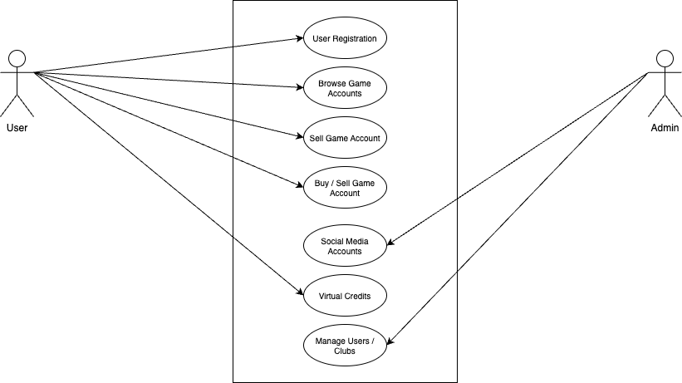

# Activity Diagrams

## Admin

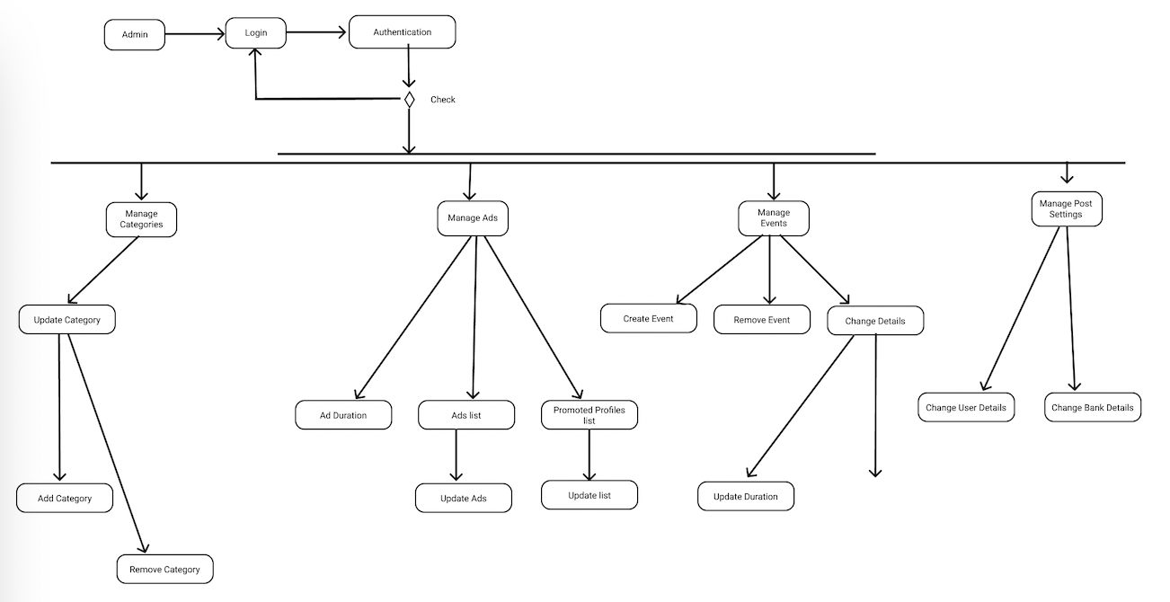

## User

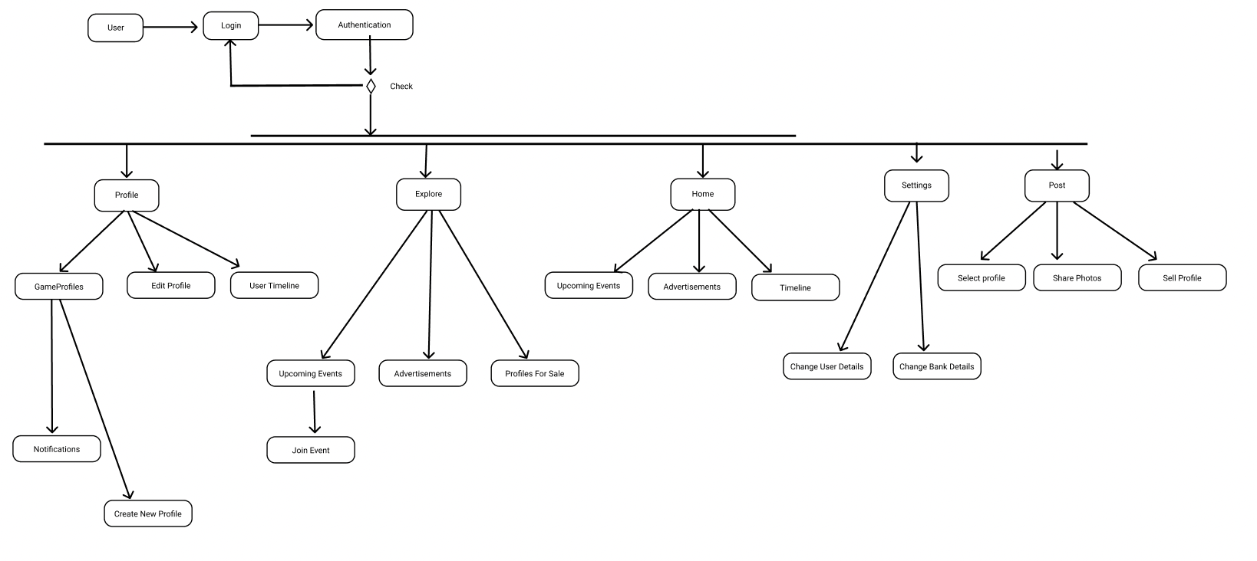

## **Architecture**

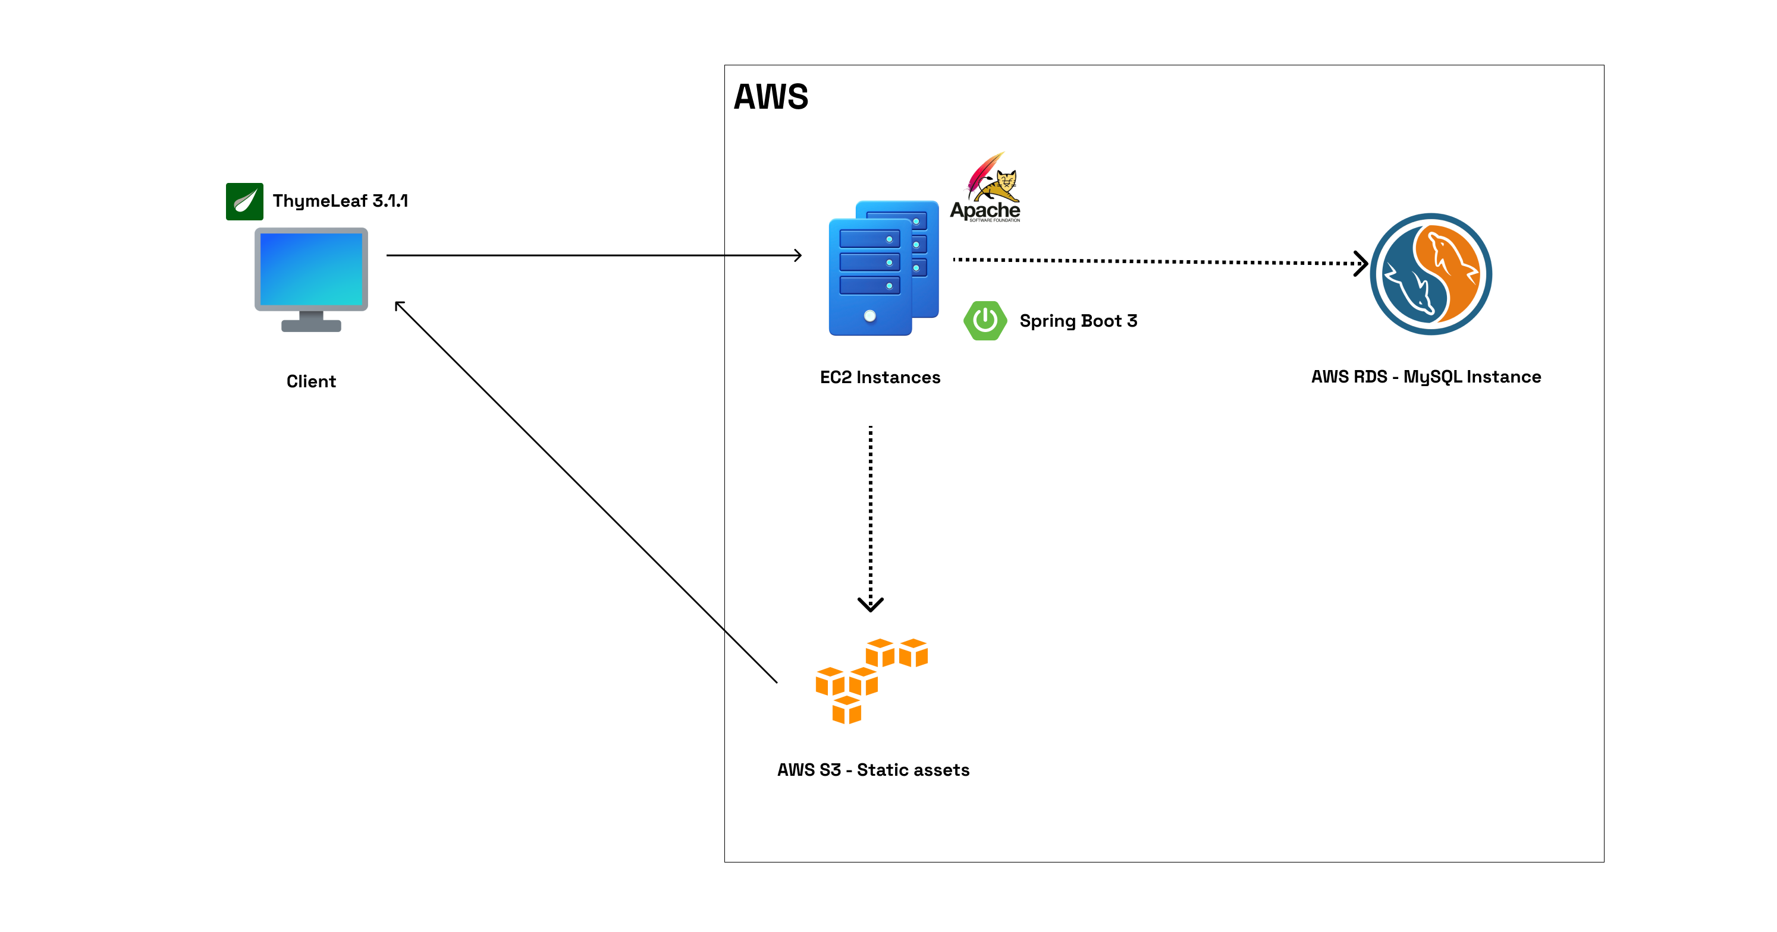

# **Wireframes**

Table



wireframe : Landing Page

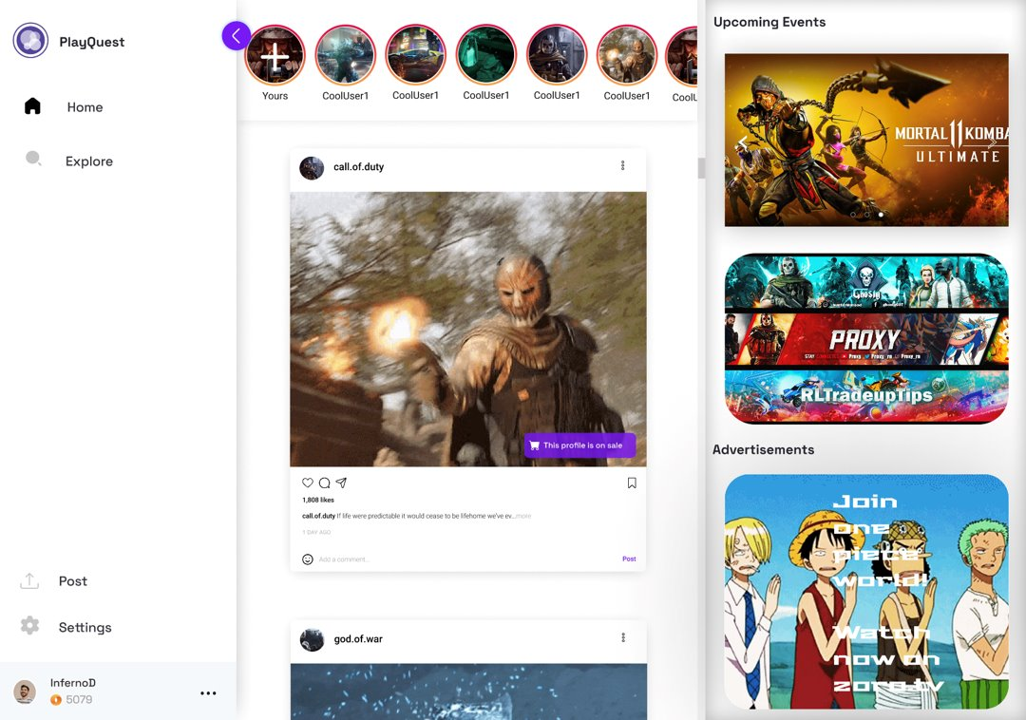

wireframe : Home page

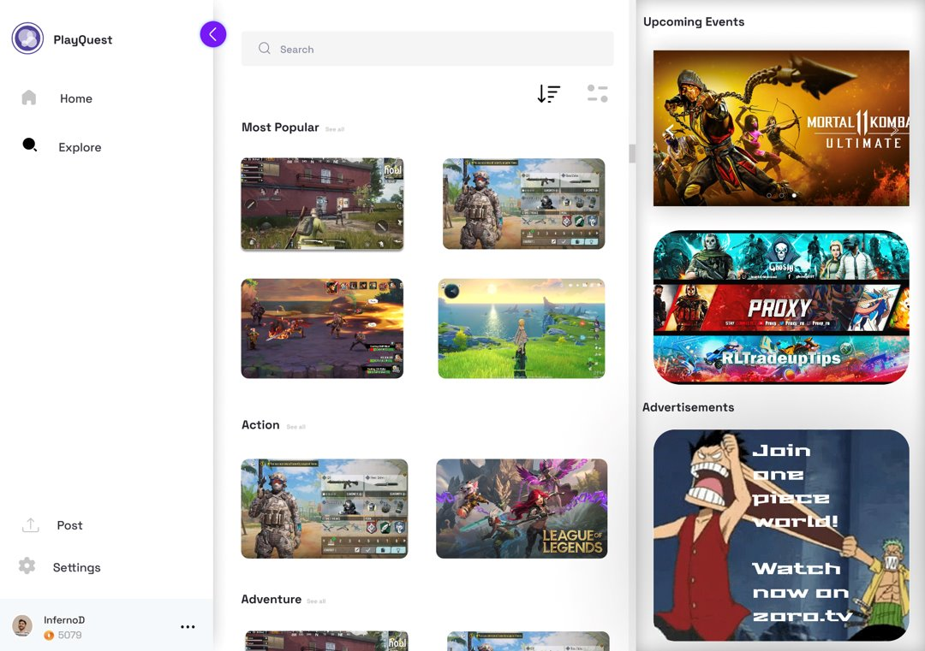

wireframe : Explore Page

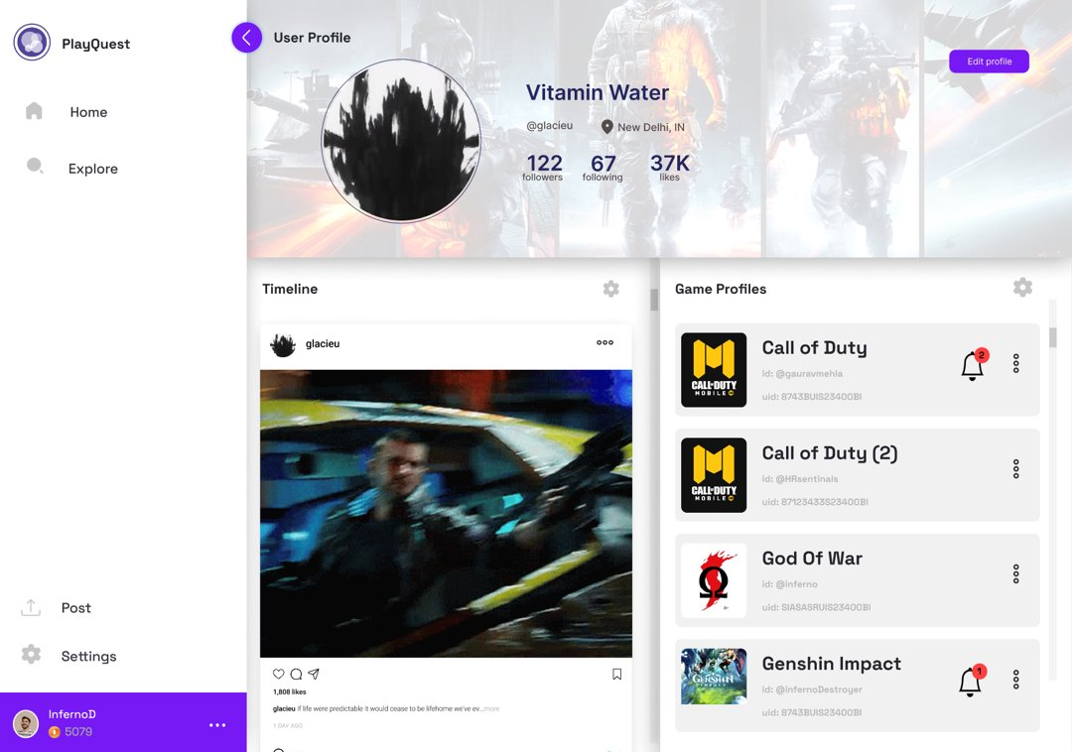

wireframe : Profile Page

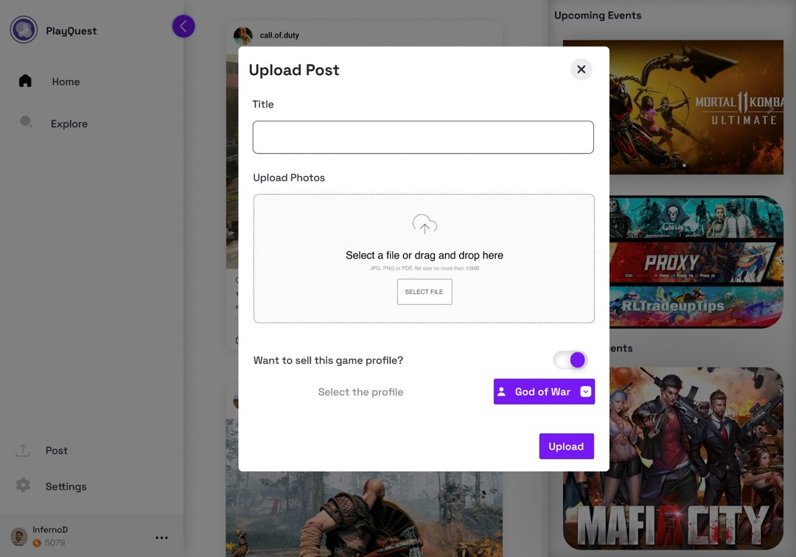

wireframe : Post Page

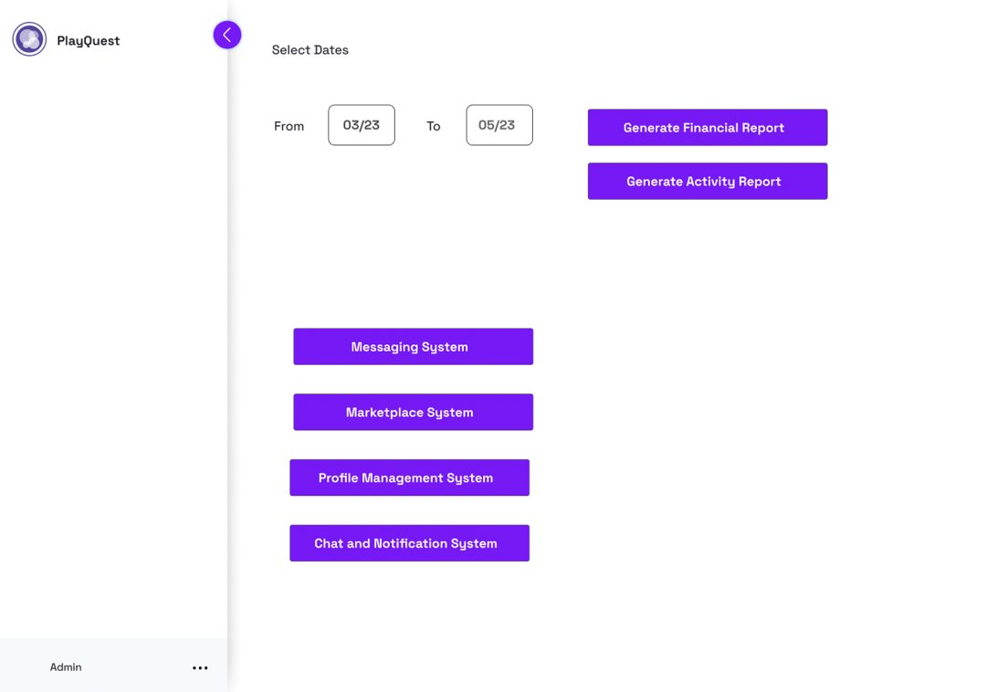

wireframe : Admin Page

# System Design

The platform aims to provide a streamlined, trusted user experience for buying and selling game profiles and also allowing them to post and share their progress.

## Database Structure

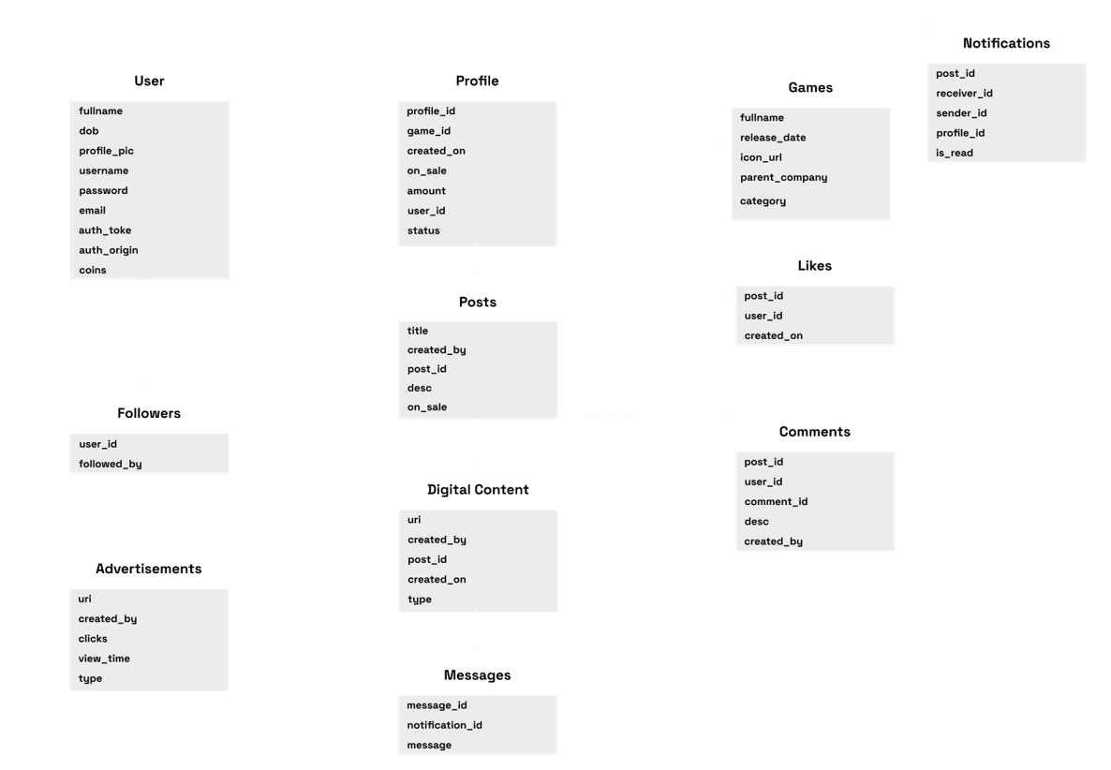

diagram : database

## Sequence Diagram

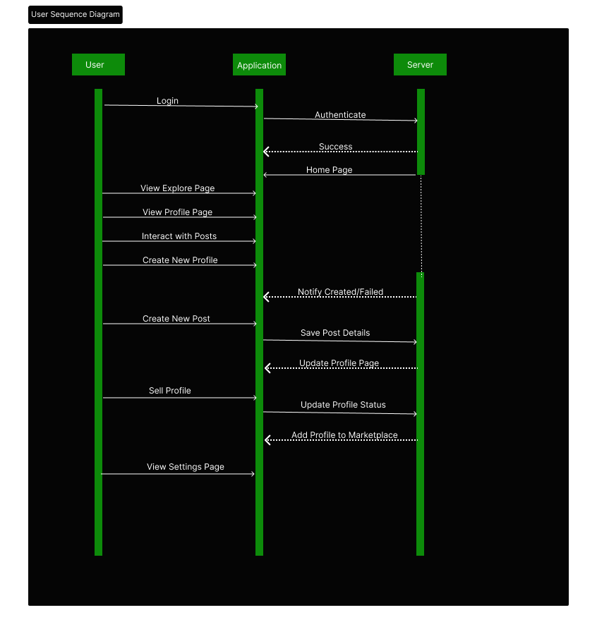

diagram : User Sequence Diagram

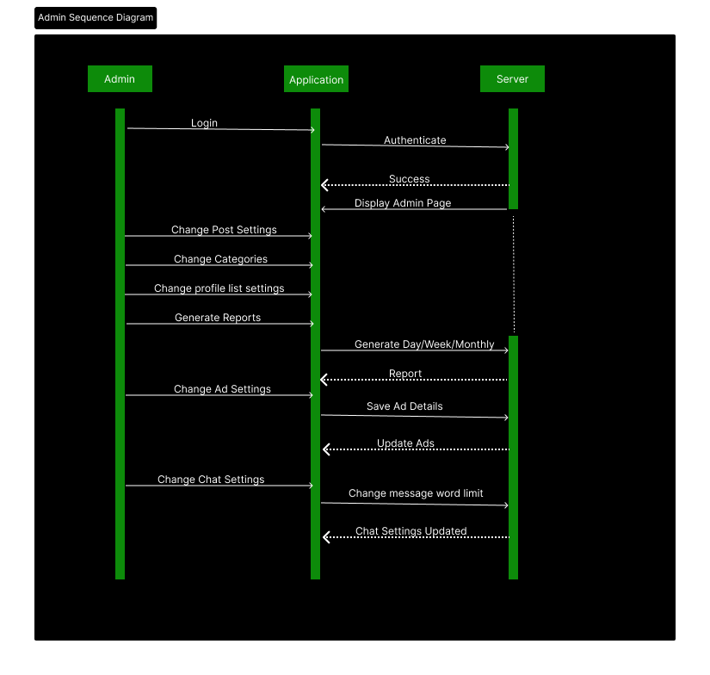

diagram : Admin Sequence Diagram

# Security and Compliance

- HTTPS encryption will secure all data transmission

- Input validation will sanitize user-entered data

- Cloud-based firewalls and DDoS prevention will counter infrastructure attacks

- Role-based access controls will limit employee permissions

- GDPR and global data privacy regulations will be followed

## **Development and Testing**

### Code Implementation

- Frontend built using Thymeleaf and Bootstrap class for component-based UX development

- Backend uses Java with Spring boot framework for API routing

- MySQL provides a flexible, scalable database.

### Testing and QA

- Junit and Mockito testing framework enables extensive unit testing

- GitHub issues are used to track bugs during development

- AWS Bean Stalk for deployment.

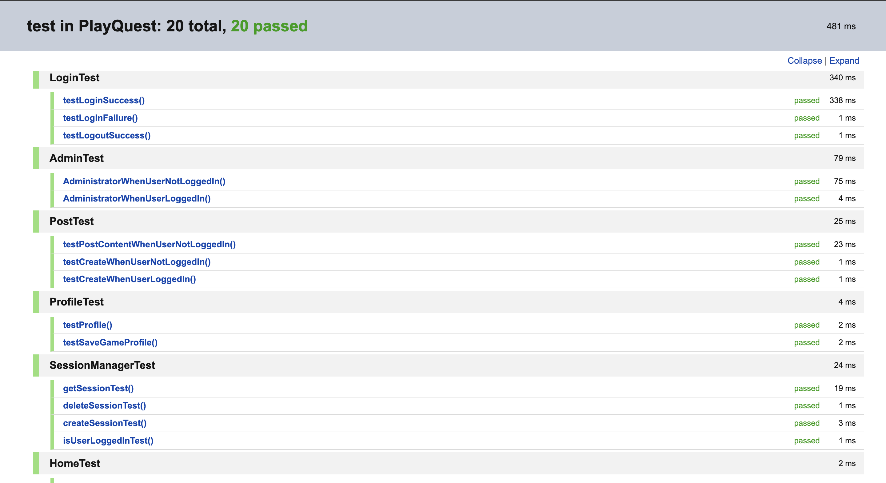

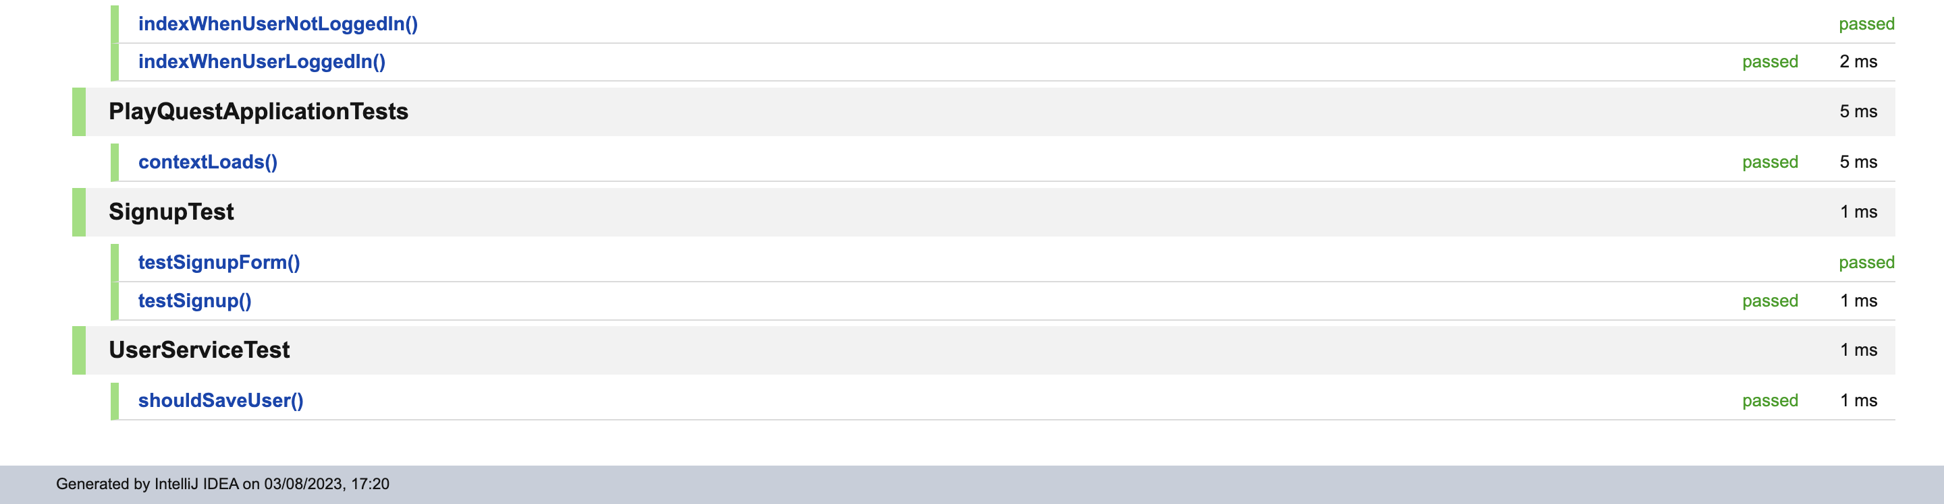

Testing Report

## **Route Structure**

/

|- /login GET Show login page

|- /login POST Authenticate and redirect to homepage

|- /logout GET Delete Session and redirect to login page

|- /signup GET Redirects to signup page

|- /signup POST Redirects to login page

|- / GET Display homepage and ads

|- /create GET Show the post creation form

|- /create POST Store the information in the database

|- /sendnotify POST Send the post notification

|- /updatelikes POST Add a like on a post

|- /post/{id} GET Display post details

|- /post/{id} DEL Delete the post

|- /profile/{id} GET Display user profile

|- /profile/u/{id} GET Display user profile of others

|- /profile/edit GET Open edit profile

|- /updateProfile/{userId} POST Update user and redirect to profile

|- /save-game-profile POST Save new game profile

|- /save-game-profile POST Delete game profile

|- /notifications GET Display notification page

|- /notification/{id} DEL Delete and redirect to notification page

|- /settings GET Display settings page

|- /admin GET Display admin homepage

|- /admin/ads GET Display admin ads panel

|- /admin/ads POST Save new ads

|- /admin/users GET Display admin user panel

|- /admin/users/{id} GET Get a user details

|- /admin/users/create POST Create a new user

|- /admin/users/update/{id} GET Update users page

|- /admin/users/update/{id} POST Update user and redirect to admin user panel

|- /admin/users/delete/{id} GET Delete a user

|- /admin/games GET Display games panel

|- /admin/games/save POST Save a game

## **Project Screenshots**

